

**A Project Report On**

**AUTOMATION TESTING ON ORANGEHRM WEBSITE**

**By**

**Vedika Kamble**

**Batch: (2021-5764)**

**Course: S Prayas-Certified Software Test Engineer**

**Under the Guidance of, Priyanka Desale (Technical Trainer) EduBridge**

**INTRODUCTION**

This Project aims to do overall testing like functional testing, GUI testing on website to check quality of application. It helps to improve quality of website and saves time for manually doing this testing. In this project our main focus is to check functionalities available on website. Also, it includes title check and all links count with their working status.

**SOFTWARE REQUIREMENTS**

* Operating System: Windows 10
* Browser: Latest version of Chrome
* IDE: Eclipse IDE
* Automation Tool: Selenium WebDriver
* Front-end: Java

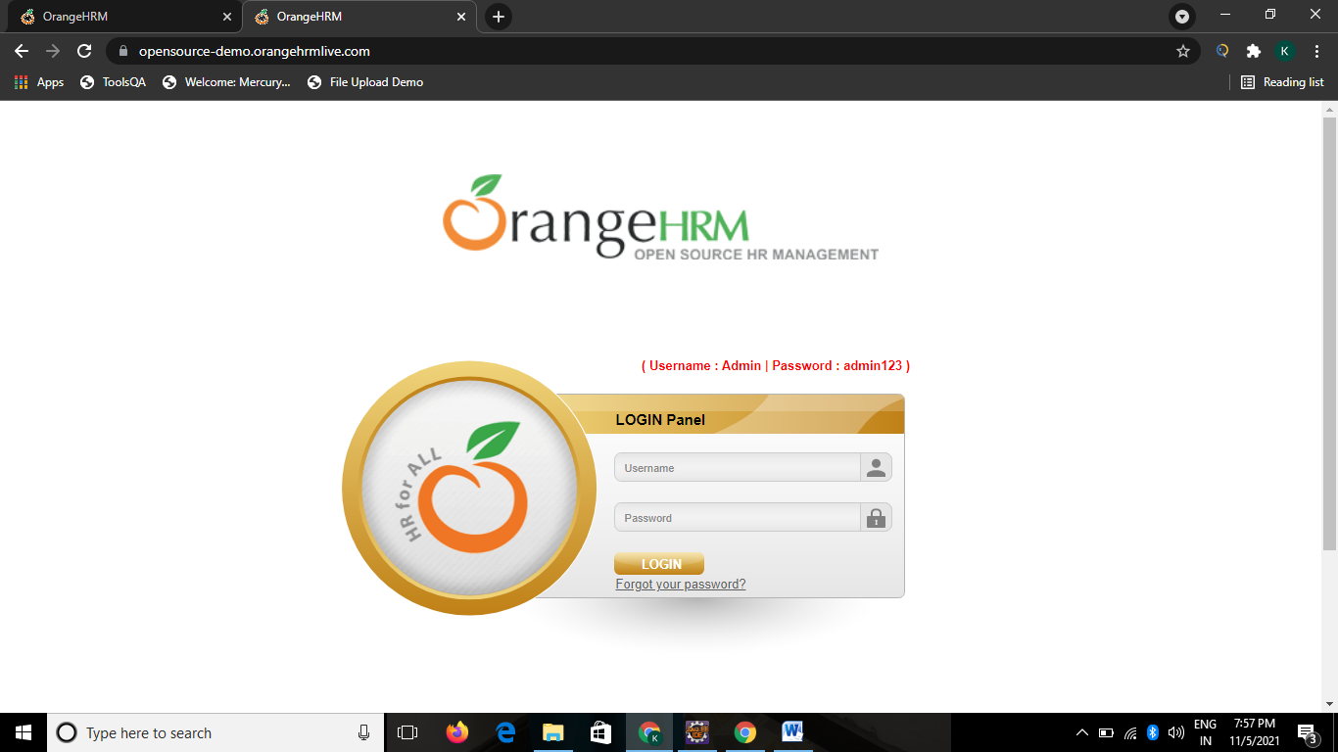

# TC01- Launch the browser and open orangeHRM Website.

System.setProperty("webdriver.chrome.driver”,”c:\\chromdriver.exe”);

WebDriver w=new ChromeDriver();

w.get(<https://opensourcedemo.orangehrmlive.com/>);



# TC02-To check the functionality of Login button with valid username and password

w.manage().window().maximize();

w.findElement(By.name(“txtUsername”)).sendkeys(“Admin”);

w.findelement(By.name(“txtPassword”)).sendkeys(“Admin123”);

w.findelement(By.name(“Submit)).click();

# TC03-To Check the functionality of Admin Button

w.findElement(Byxpath("//*[@id=\"menu_admin_viewAdminModu

le\"]/b")).click()

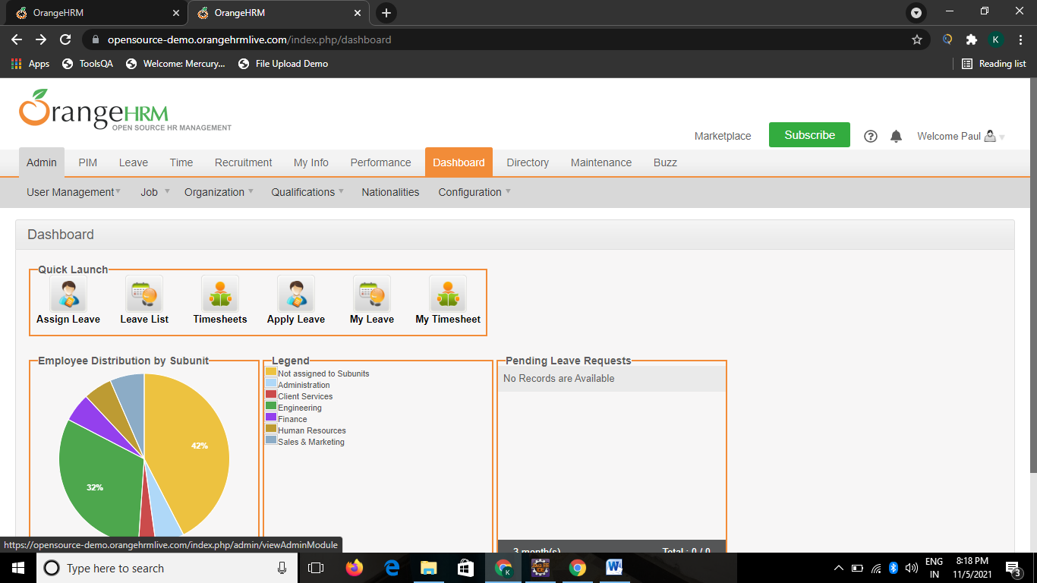

# TC04-To Check the Functionality of Add Button

# 

w.findElement(By.id("btnAdd")).click();

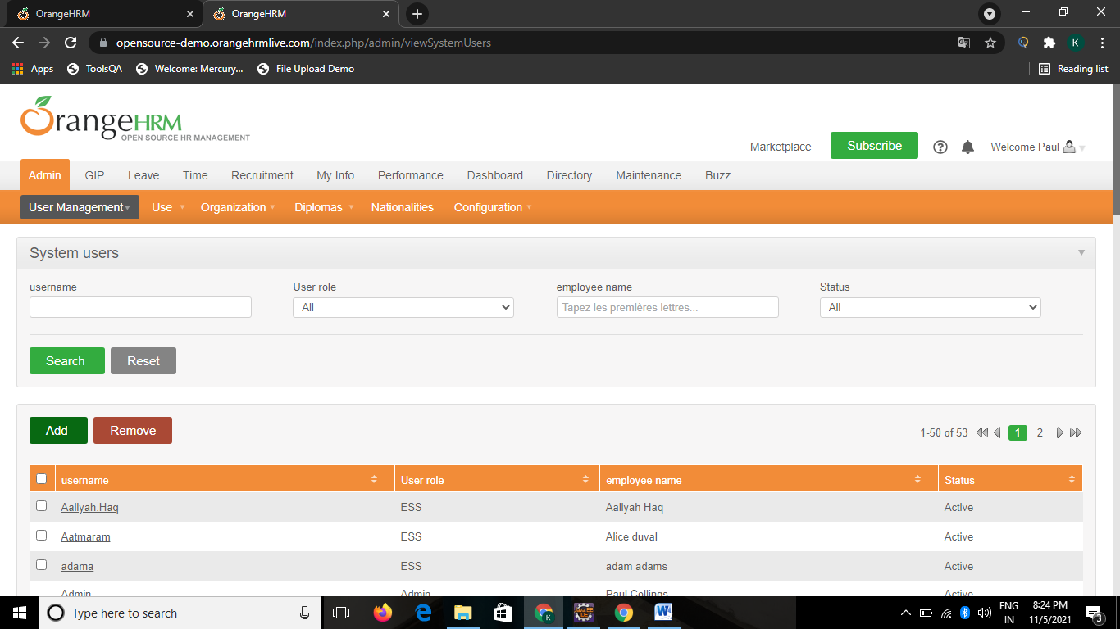

**TC05-To Check the Functionality Save Button**

Select s = new Select(w.findElement(By.name("systemUser[userType]")));

s.selectByVisibleText("Admin");

w.findElement(By.name("systemUser[employeeName][empName]")).sendKeys("Jasmine Morgan");

w.findElement(By.name("systemUser[userName]")).sendKeys("jasmo");

Select s1 = **new** Select(w.findElement(By.name("systemUser[status]")));

s1.selectByVisibleText("Enabled");

w.findElement(By.name("systemUser[password]")).sendKeys("jasmo123");

w.findElement(By.name("systemUser[confirmPassword]")).sendKeys("jasmo123");

w.findElement(By.name("btnSave")).click();

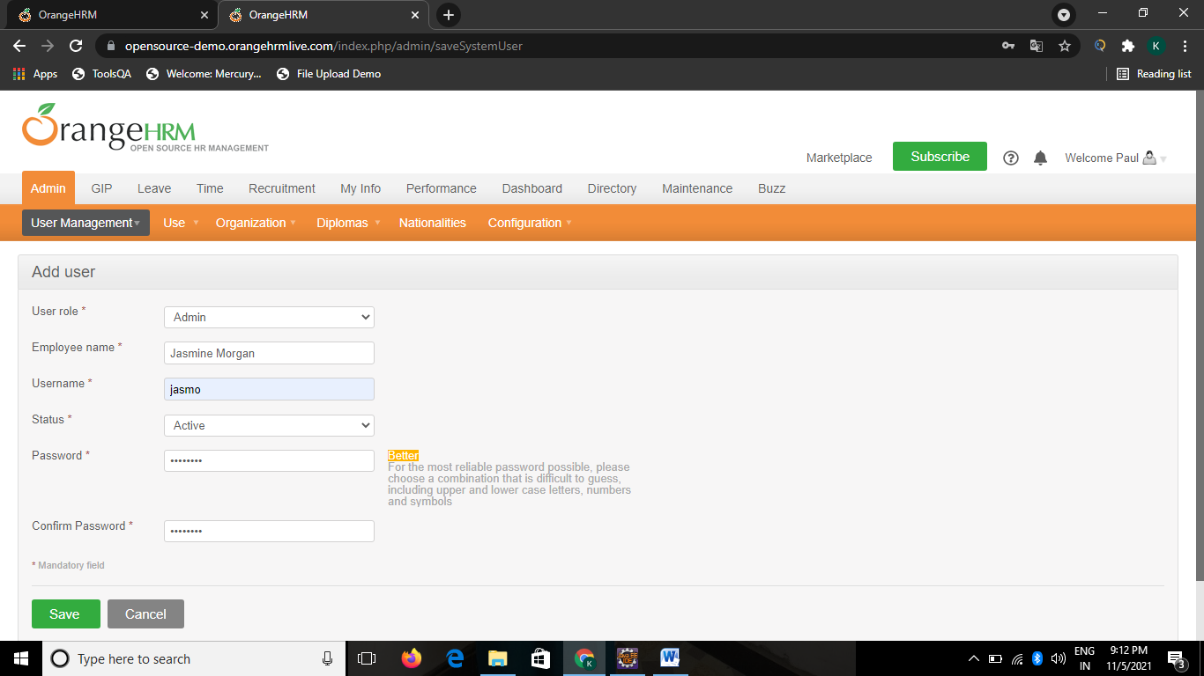

**TC06-To check the functionality of Search Button**

w.findElement(By.id("searchSystemUser_userName")).sendKeys("Jasmo");

Select s2 = **new** Select(w.findElement(By.id("searchSystemUser_userType")));

s2.selectByValue("1");

w.findElement(By.id("searchSystemUser_employeeName_empName")).sendKeys("Jasmine Morgan");

Select s3 = **new** Select(w.findElement(By.id("searchSystemUser_status")));

s3.selectByValue("1");

w.findElement(By.name("_search")).click();

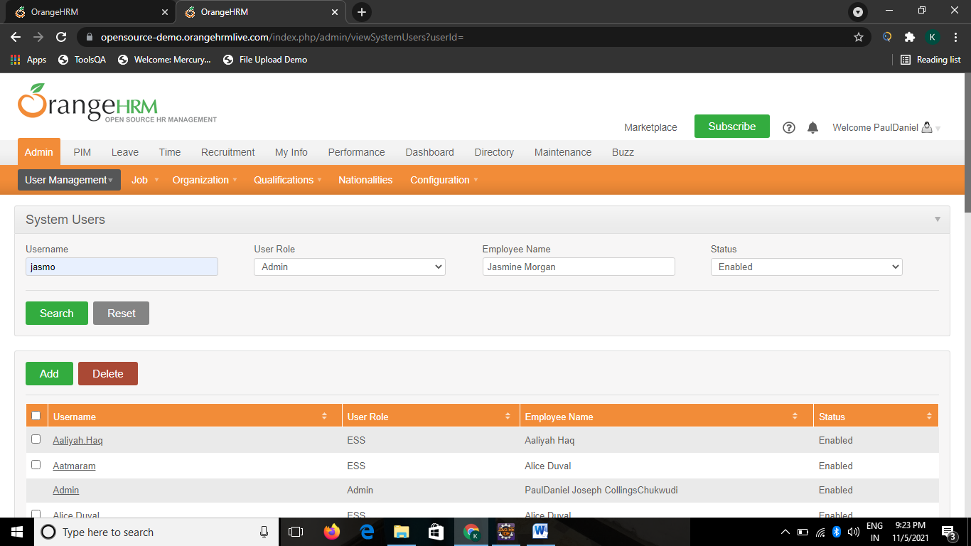

**TC07-To Check the functionality of User Management with User Button**

Actions A = **new** Actions(w);

A.moveToElement(w.findElement(By.linkText("User

Management"))).build().perform();

w.findElement(By.linkText("Users")).click();

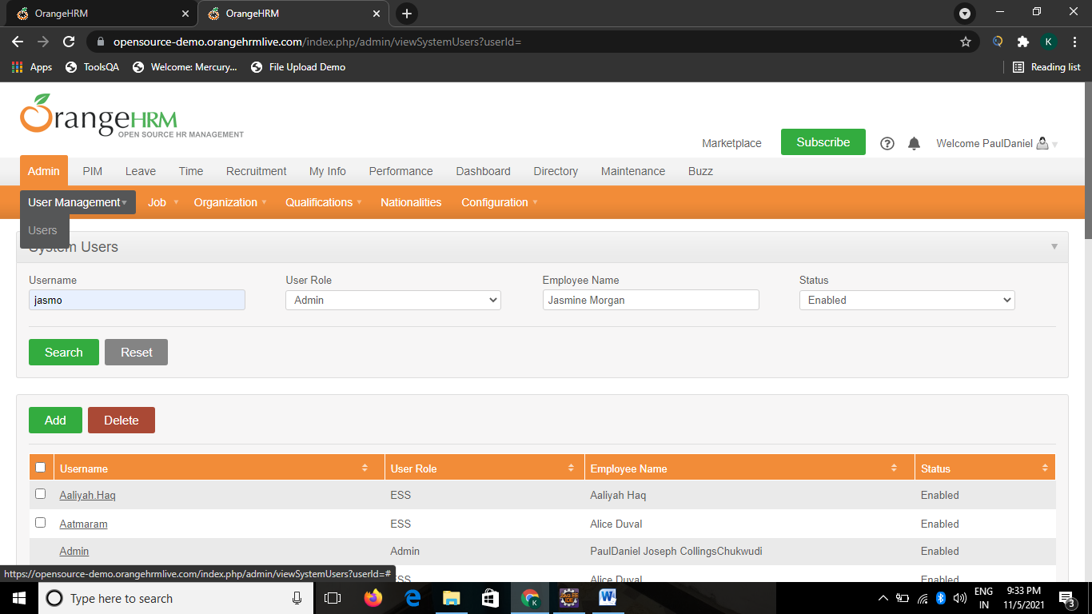

**TC08-To Check the functionality of Job with job titles Button**

Actions A1 = **new** Actions(w);

A1.moveToElement(w.findElement(By.linkText("Job"))).build().perform();

w.findElement(By.linkText("Job Titles")).click();

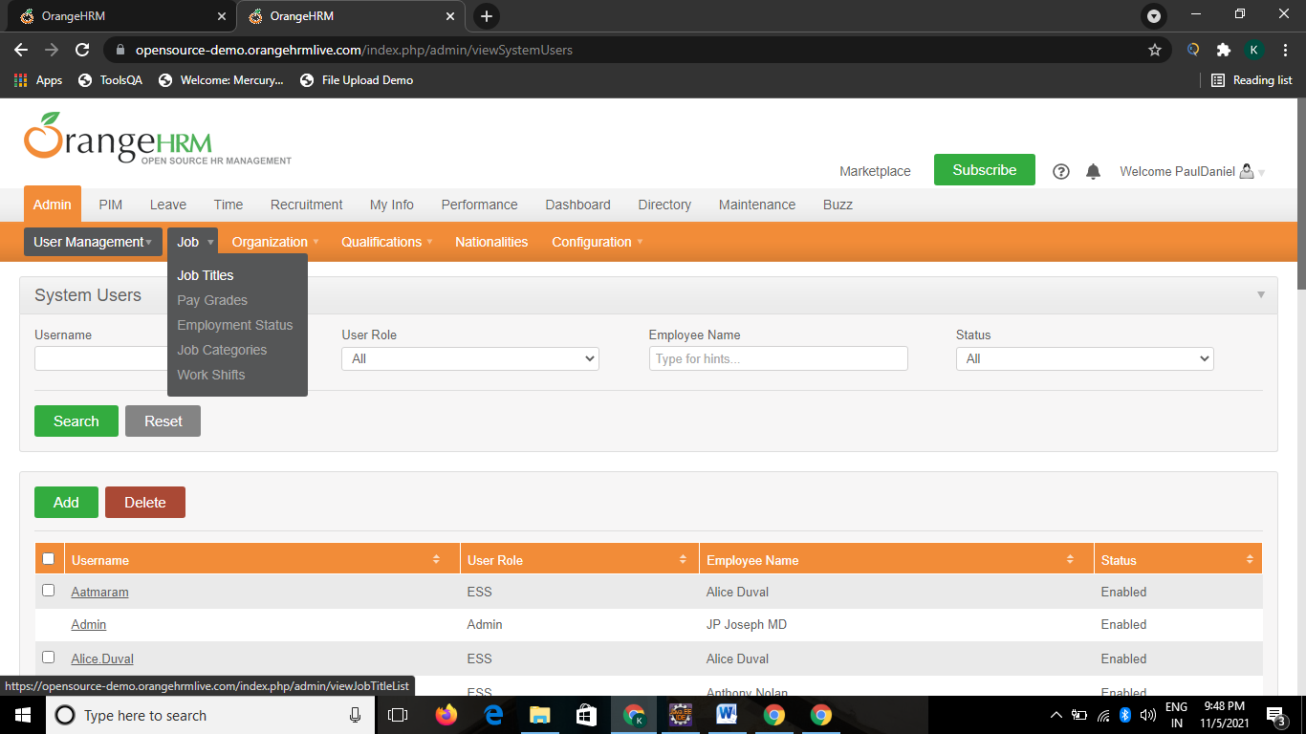

# TC09-To check the functionality of Add and Save Button

w.findElement(By.name("btnAdd")).click();

w.findElement(By.name("jobTitle[jobTitle]")).sendKeys("IT Manager2");

w.findElement(By.xpath("//*[@id=\"btnSave\"]")).click();

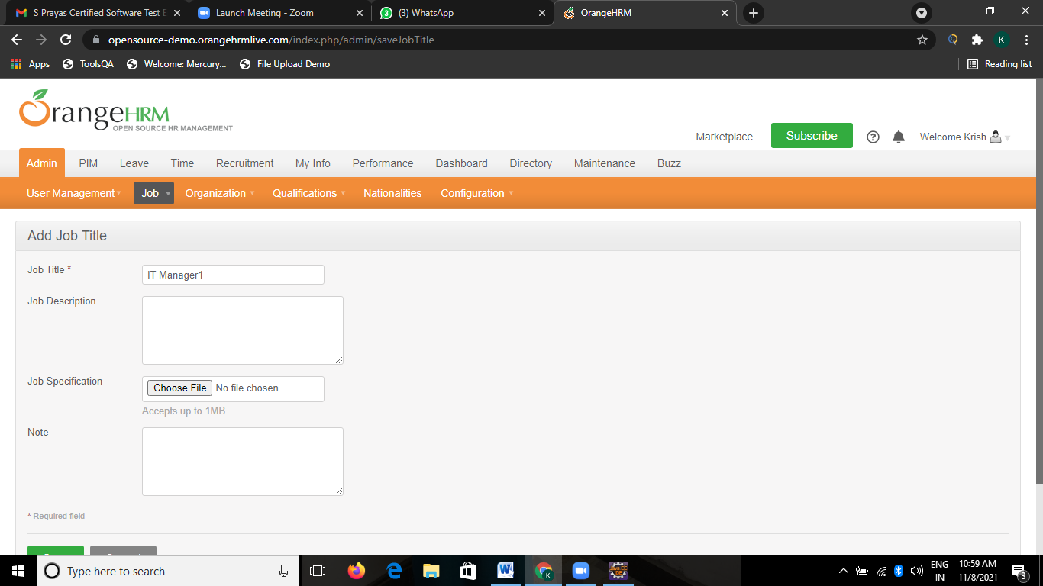

# TC10-To check the functionality of Delete Button

w.findElement(By.xpath("//*[@id=\"resultTable\"]/tbody/tr[1]/td[2]/a")).click();

w.findElement(By.name("btnDelete")).click();

w.findElement(By.id("dialogDeleteBtn")).click();

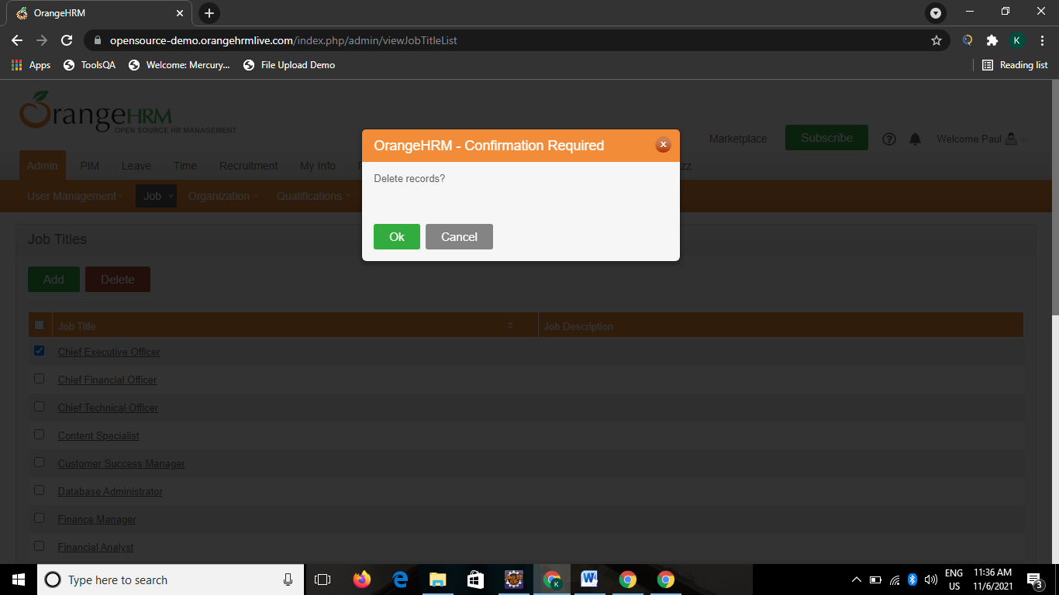

# TC11-To check the functionality of Job with pay grade Button

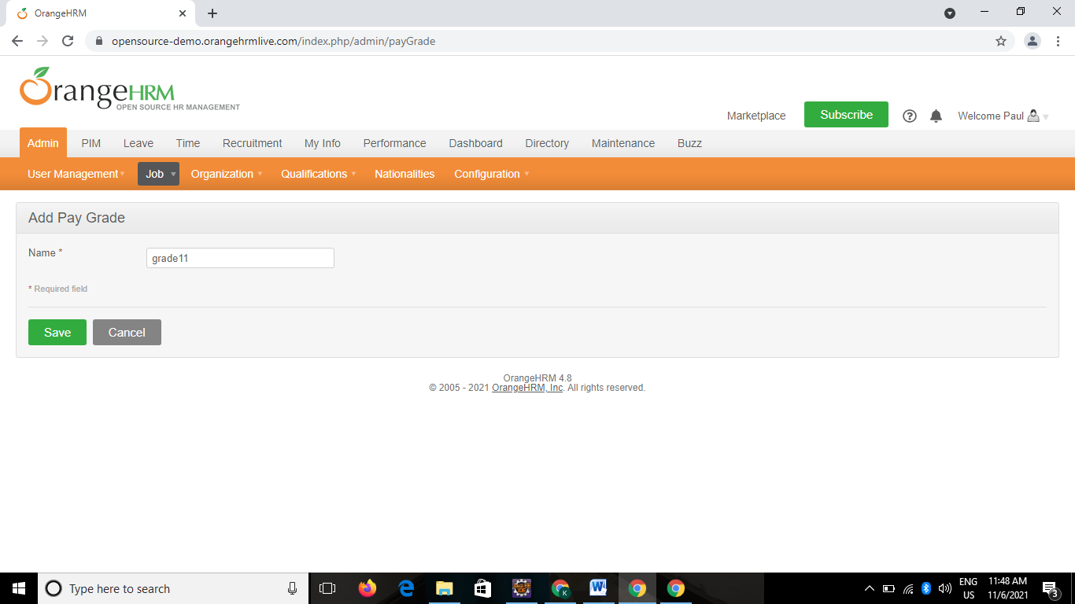Actions A3 = **new** Actions(w);

A3.moveToElement(w.findElement(By.linkText("Job"))).build().perform();

w.findElement(By.linkText("Pay Grades")).click();

w.findElement(By.xpath("//*[@id=\"btnAdd\"]")).click();

w.findElement(By.name("payGrade[name]")).sendKeys("Grade10");

w.findElement(By.xpath("//*[@id=\"btnSave\"]")).click();

# TC12-To check the functionality of Add Currency Button

w.findElement(By.id("btnAddCurrency")).click();

w.findElement(By.name("payGradeCurrency[currencyName]")).sendKeys("USD

- United States Dollar");

w.findElement(By.name("payGradeCurrency[minSalary]")).sendKeys("50000");

w.findElement(By.name("payGradeCurrency[maxSalary]")).sendKeys("60000");

w.findElement(By.name("btnSaveCurrency")).click();

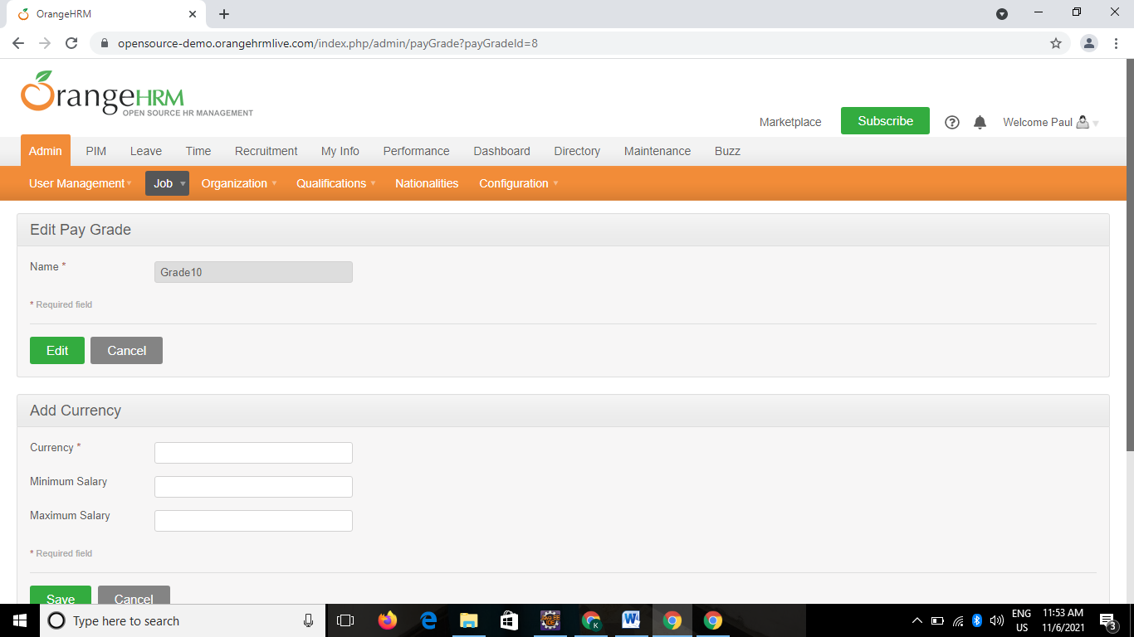

# TC13-To check the functionality of Job with Employment Status Button

Actions A4 = **new** Actions(w);

A4.moveToElement(w.findElement(By.linkText("Job"))).build().perform();

w.findElement(By.linkText("Employment Status")).click();

w.findElement(By.xpath("//*[@id=\"btnAdd\"]")).click();

w.findElement(By.name("empStatus[name]")).sendKeys("Freelance1");

w.findElement(By.xpath("//*[@id=\"btnSave\"]")).click();

# TC14-To check the functionality of Job with Job category Button

Actions A5 = **new** Actions(w);

A5.moveToElement(w.findElement(By.linkText("Job"))).build().perform();

w.findElement(By.linkText("Job Categories")).click();

w.findElement(By.xpath("//*[@id=\"btnAdd\"]")).click();

w.findElement(By.name("jobCategory[name]")).sendKeys("Craft Workers1");

w.findElement(By.xpath("//*[@id=\"btnSave\"]")).click();

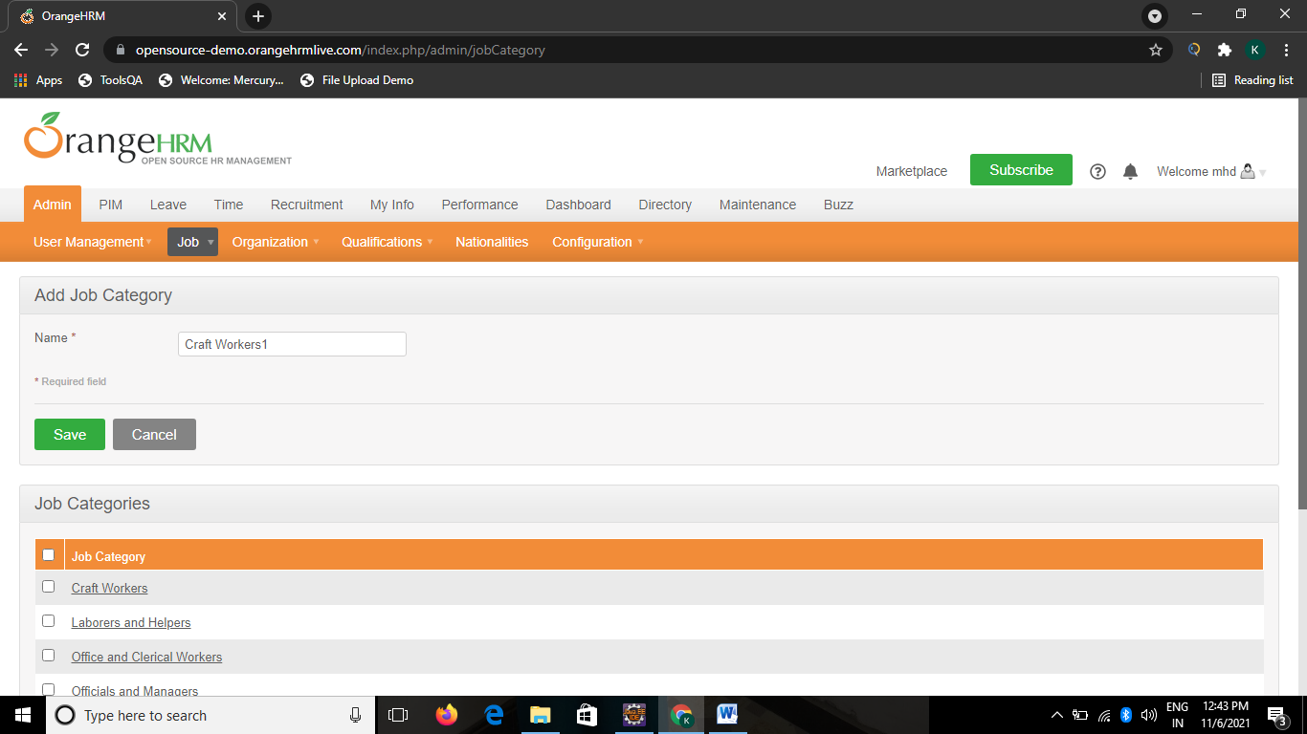

**TC15-To check the functionality of Job with Work shift Button**

Actions A6 = **new** Actions(w);

A6.moveToElement(w.findElement(By.linkText("Job"))).build().perform();

w.findElement(By.linkText("Work Shifts")).click();

w.findElement(By.xpath("//*[@id=\"btnAdd\"]")).click();

w.findElement(By.name("workShift[name]")).sendKeys("General1");

Select s2 = **new** Select(w.findElement(By.name("workShift[workHours][from]")));

s2.selectByVisibleText("01:15");

Select s3 =**new** Select(w.findElement(By.name("workShift[workHours][to]")));

s3.selectByVisibleText("04:00");

w.findElement(By.xpath("//*[@id=\"btnSave\"]")).click();

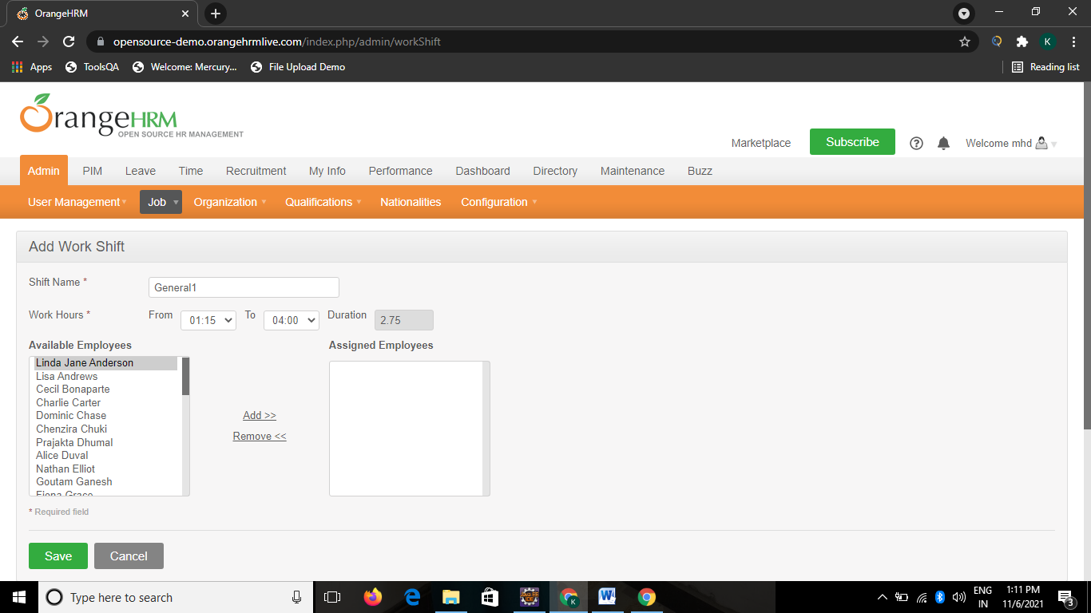

# TC16-To check the functionality of Organization with general information Button

Actions A7 = **new** Actions(w);

A7.moveToElement(w.findElement(By.linkText("Organization"))).build().perform();

w.findElement(By.linkText("General Information")).click();

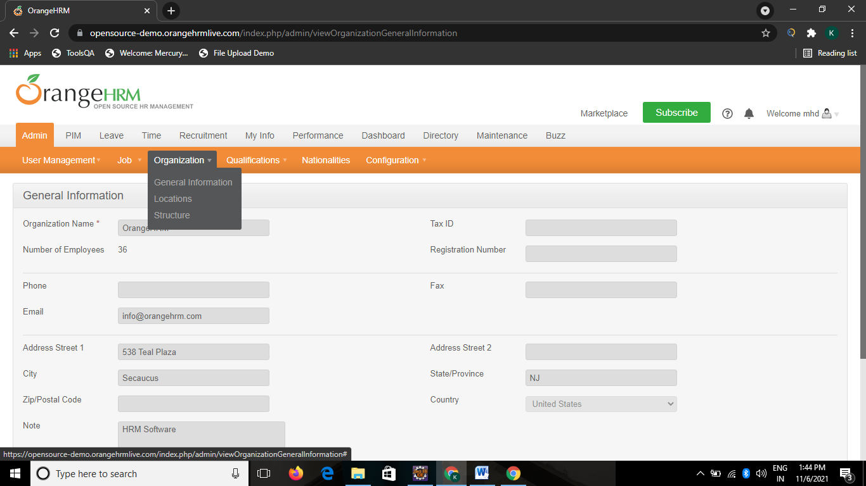

# TC17-To check the functionality of Edit Button.

w.findElement(By.name("btnSaveGenInfo")).click();

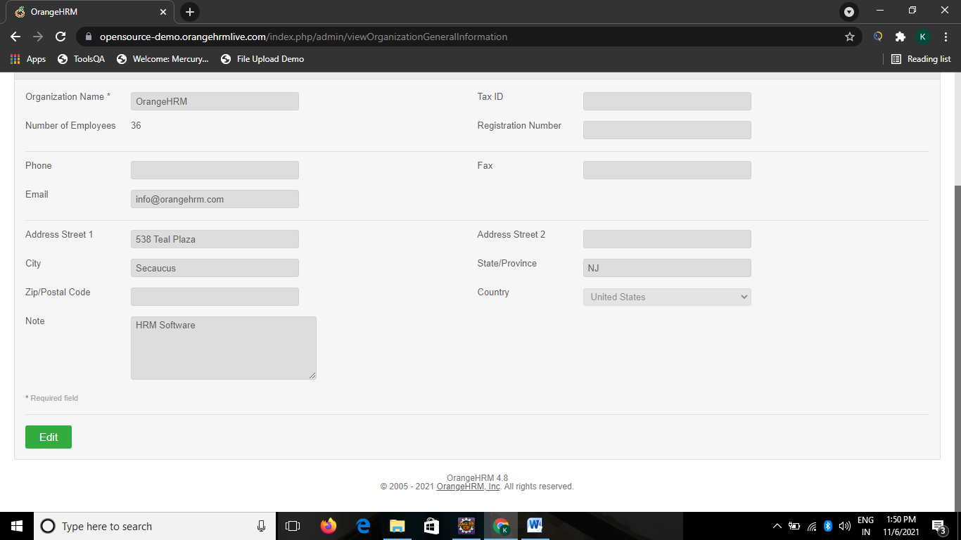

**TC18-To check the functionality of Organization with location Button**

Actions A6 = **new** Actions(w);

A6.moveToElement(w.findElement(By.linkText("Organization"))).build().perform();

w.findElement(By.linkText("Locations")).click();

w.findElement(By.xpath("//*[@id=\"btnAdd\"]")).click();

w.findElement(By.name("location[name]")).sendKeys("jasmo");

Select s4 = **new** Select(w.findElement(By.name("location[country]")));

s4.selectByVisibleText("India");

w.findElement(By.name("location[province]")).sendKeys("MH");

w.findElement(By.xpath("//input[@id='btnSave']")).click();

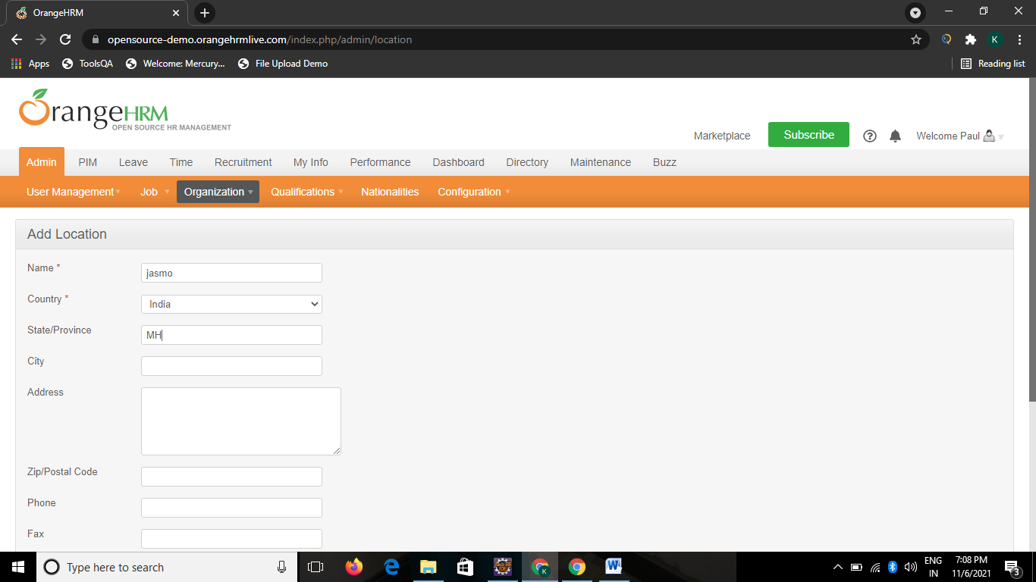

**TC19-To check the functionality of Organization with structure Button**

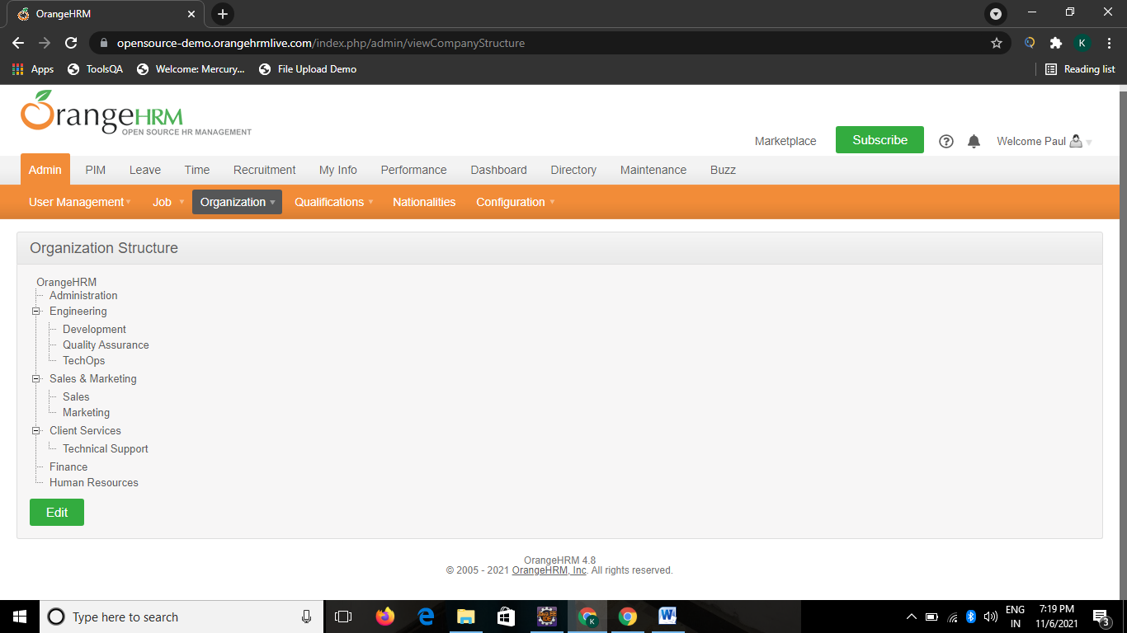 Actions A7 = **new** Actions(w);

A7.moveToElement(w.findElement(By.linkText("Organization"))).build().perform();

w.findElement(By.linkText("Structure")).click();

**TC20-To check the functionality of Qualification with Skills Button**

Actions A8 = **new** Actions(w);

A8.moveToElement(w.findElement(By.linkText("Qualifications"))).build().perform();

w.findElement(By.linkText("Skills")).click();

w.findElement(By.xpath("//input[@id='btnAdd']")).click();

w.findElement(By.name("skill[name]")).sendKeys("C");

w.findElement(By.name("skill[description]")).sendKeys("Programming lang");

w.findElement(By.xpath("//input[@id='btnSave']")).click();

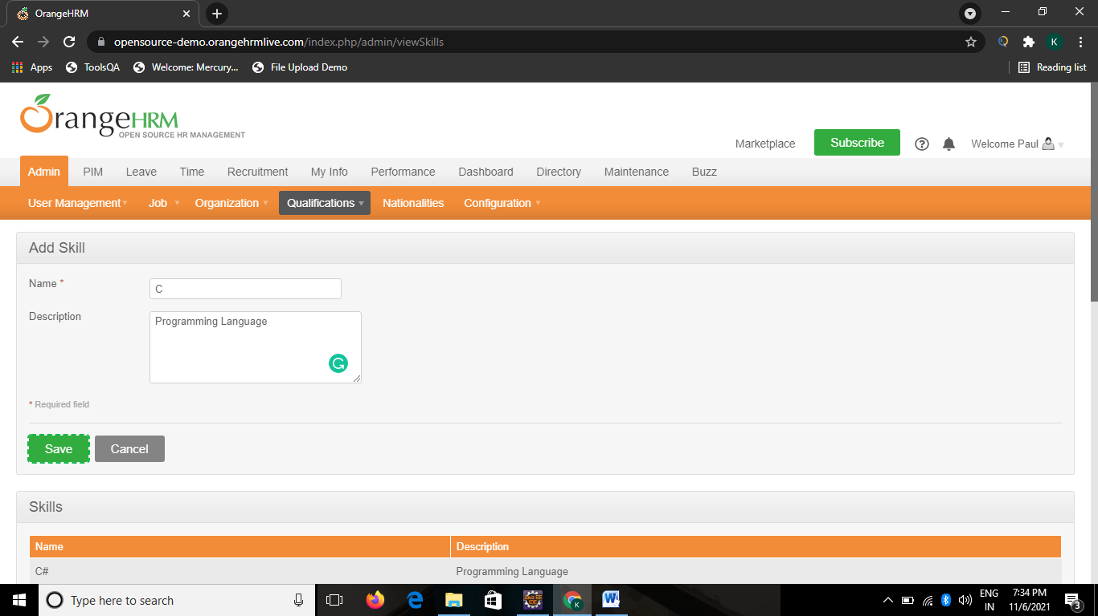

**TC21-To check the functionality of Qualification with Education**

Actions A9 = **new** Actions(w);

A9.moveToElement(w.findElement(By.linkText("Qualifications"))).build().perform();

w.findElement(By.linkText("Education")).click();

w.findElement(By.xpath("/html[1]/body[1]/div[1]/div[3]/div[2]/div[2]/form[1]/p[1]/input[1]")).click();

w.findElement(By.name("education[name]")).sendKeys("BE");

w.findElement(By.xpath("/html[1]/body[1]/div[1]/div[3]/div[1]/div[2]/form[1]/fieldset[1]/p[1]/input[1]")).click();

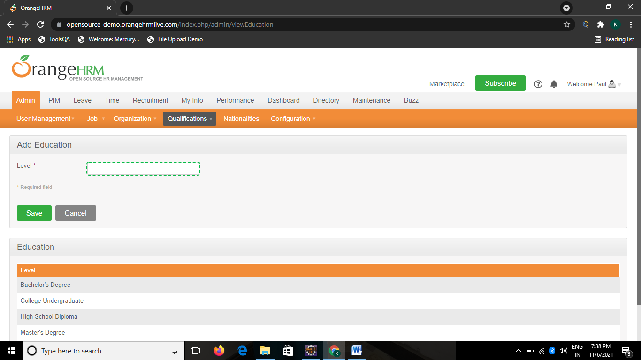

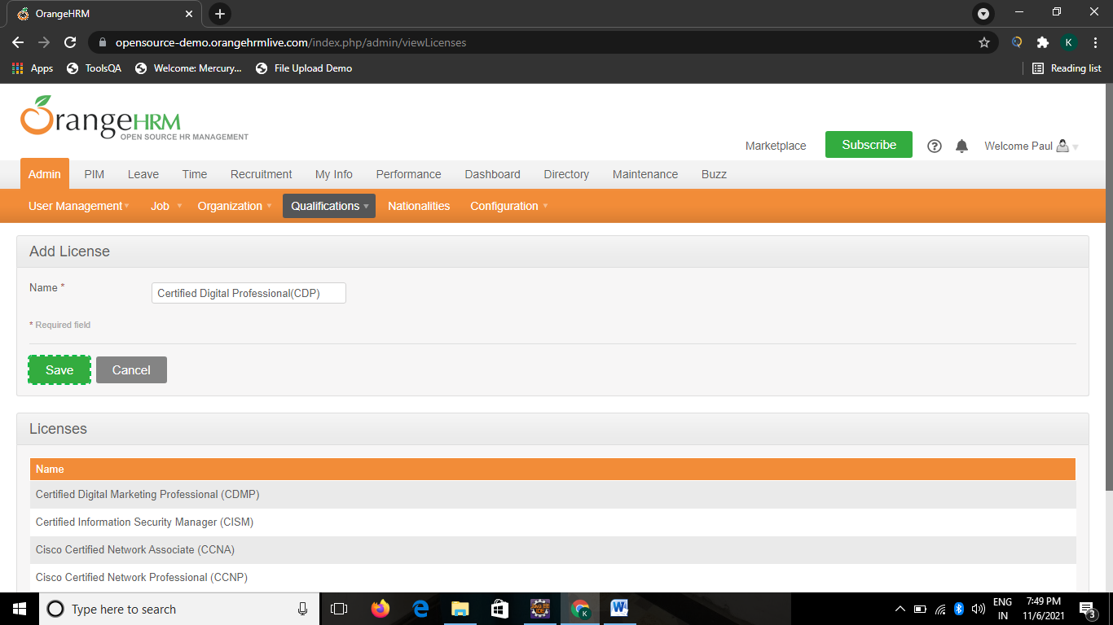**TC22-To check the functionality of Qualification with Licenses Button**

Actions A10 = new Actions(w);

A10.moveToElement(w.findElement(By.linkText("Qualifications"))).build().perform();

w.findElement(By.linkText("Licenses")).click();

w.findElement(By.xpath("//input[@id='btnAdd']")).click();

w.findElement(By.name("license[name]")).sendKeys("CertifiedDigital Professional(CDP)");

w.findElement(By.xpath("//input[@id='btnSave']")).click();

**TC23-To Check the Functionality of Qualification with Language Button**

Actions A11 = **new** Actions(w);

A11.moveToElement(w.findElement(By.linkText("Qualifications"))).build().perform();

w.findElement(By.linkText("Languages")).click();

w.findElement(By.xpath("//input[@id='btnAdd']")).click();

w.findElement(By.name("language[name]")).sendKeys("Japanese");

w.findElement(By.xpath("//input[@id='btnSave']")).click();

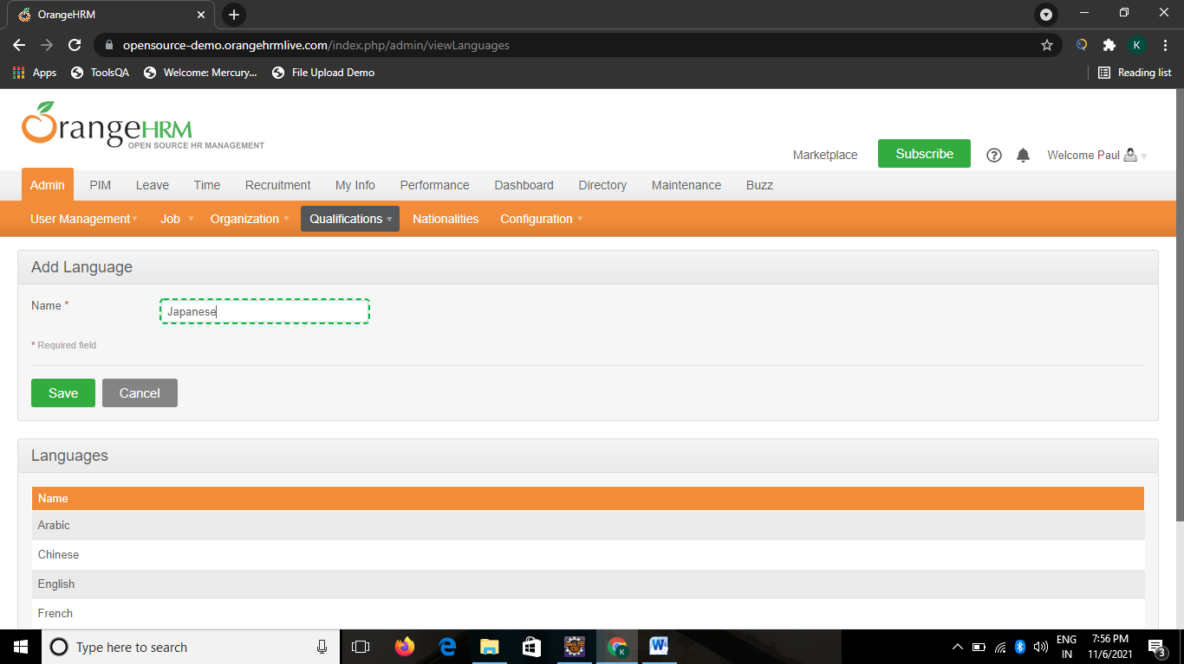

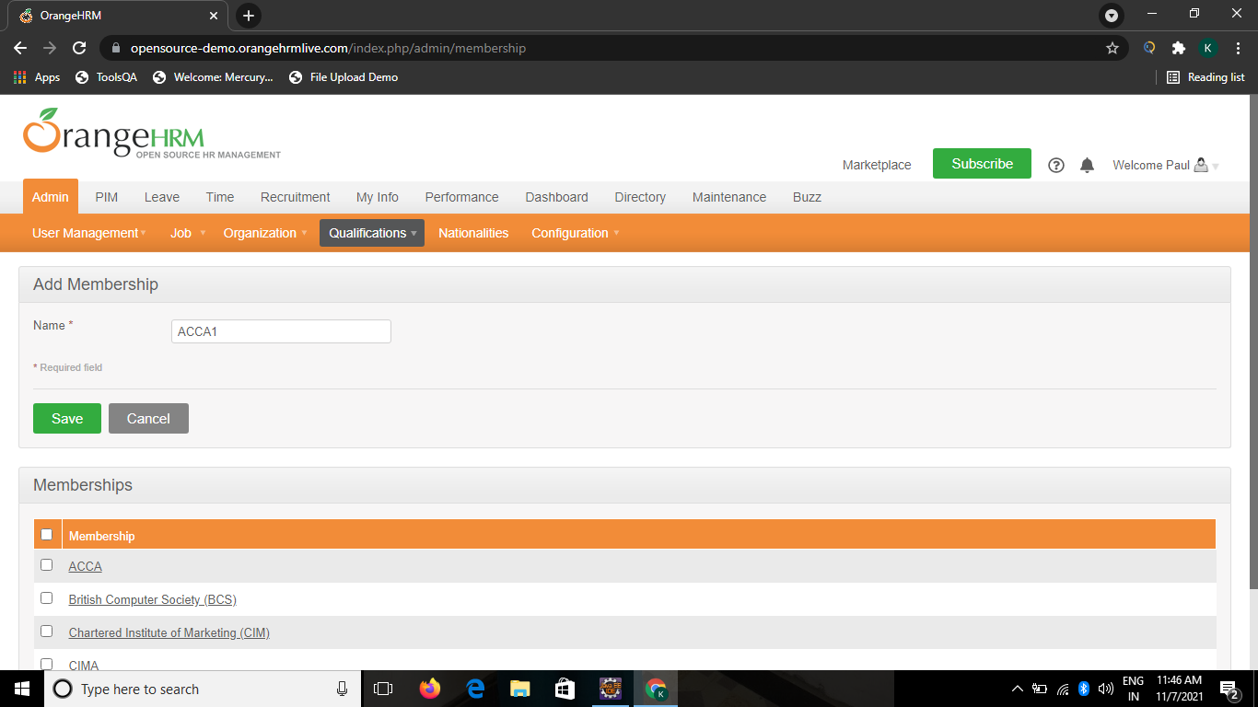**TC24-To check the functionality of Qualification with membership Button**

Actions A12 = new Actions(w);

A12.moveToElement(w.findElement(By.linkText("Qualifications"))).build().perform();

w.findElement(By.linkText("Memberships")).click();

w.findElement(By.xpath("//input[@id='btnAdd']")).click();

w.findElement(By.name("membership[name]")).sendKeys("ACCA1");

w.findElement(By.xpath("//input[@id='btnSave']")).click();

# TC25-To check the functionality of Nationalities Button

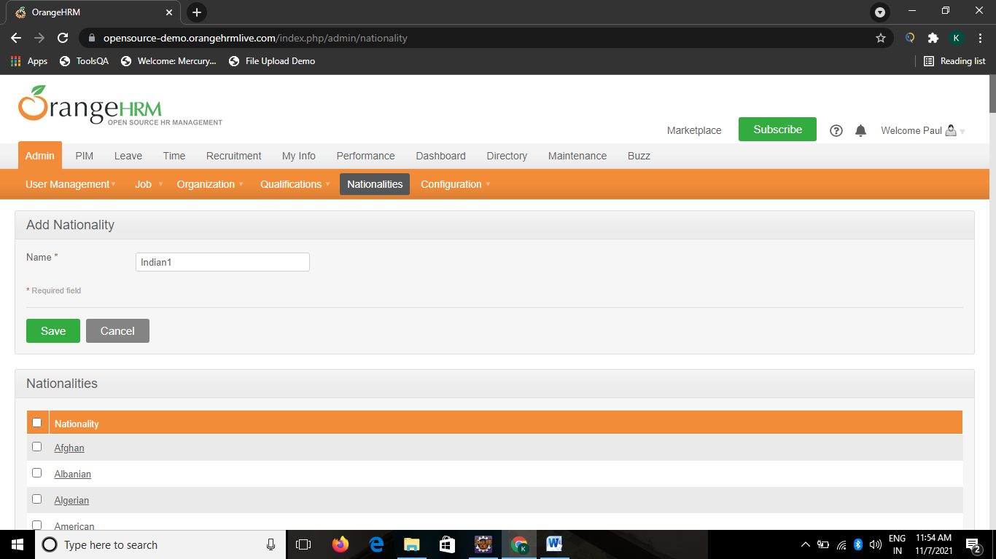w.findElement(By.linkText("Nationalities")).click();

w.findElement(By.xpath("//input[@id='btnAdd']")).click();

w.findElement(By.name("nationality[name]")).sendKeys("Indian1");

w.findElement(By.xpath("//input[@id='btnSave']")).click();

# TC26-To Check the Functionality of Configuration with email configuration Button

Actions A13 = new Actions(w);

A13.moveToElement(w.findElement(By.linkText("Configuration"))).build().perform();

w.findElement(By.linkText("Email Configuration")).click();

w.findElement(By.xpath("//*[@id=\"editBtn\"]")).click();

w.findElement(By.name("emailConfigurationForm[txtMailAddress]")).sendKeys("");

Select s5 = new Select(w.findElement(By.name("emailConfigurationForm[cmbMailSendingMethod]")));

s5.selectByVisibleText("SMTP");

w.findElement(By.xpath("//*[@id=\"emailConfigurationForm_optAuth_none\"]")).click();

w.findElement(By.name("emailConfigurationForm[txtSmtpHost]")).sendKeys("Host");

w.findElement(By.name("emailConfigurationForm[txtSmtpPort]")).sendKeys("123");

w.findElement(By.id("editBtn")).click();

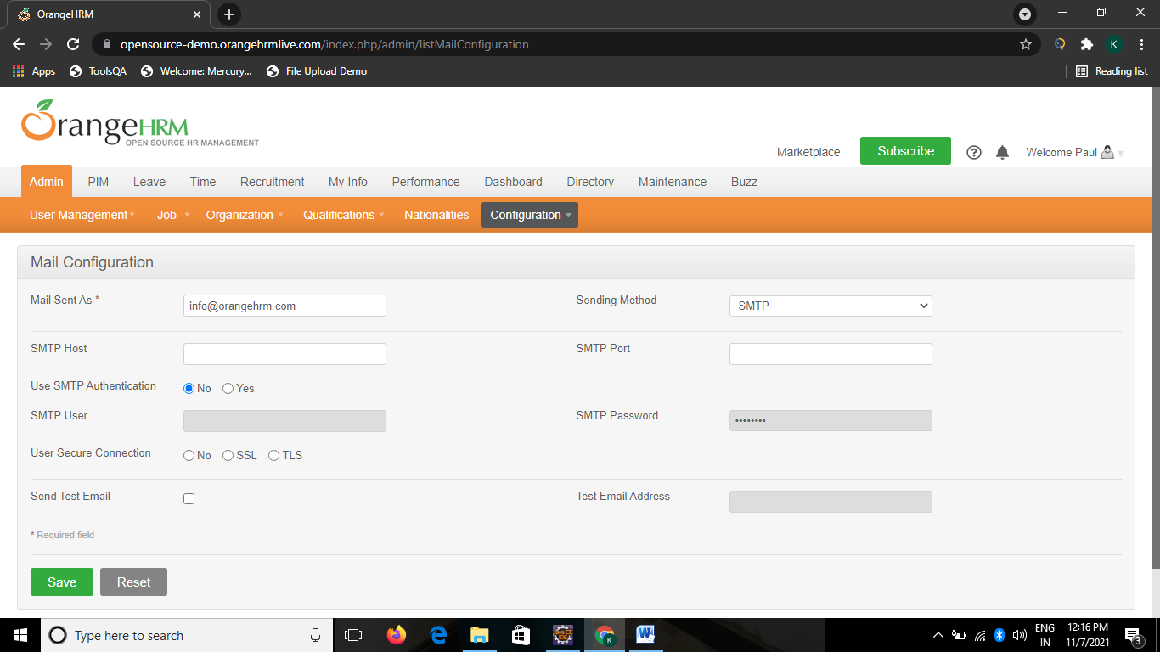

# TC27-To check the functionality of Configuration with Email Subscriptions window

Actions A14 = new Actions(w);

A14.moveToElement(w.findElement(By.linkText("Configuration"))).build().perform();

w.findElement(By.linkText("Email Subscriptions")).click();

Defect:- Edit button not giving editing options

# TC28-To check the functionality of Configuration with localization Button

Actions A15 = new Actions(w);

A15.moveToElement(w.findElement(By.linkText("Configuration"))).build().perform();

w.findElement(By.linkText("Localization")).click();

w.findElement(By.xpath("//*[@id=\"btnSave\"]")).click();

Select s6 = new Select(w.findElement(By.name("localization[dafault_language]")));

s6.selectByVisibleText("English (United States)");

Select s7 = new Select(w.findElement(By.name("localization[default_date_format]")));

s7.selectByVisibleText("DD, dd-M-yyyy ( Sunday, 07-Nov-2021 )");

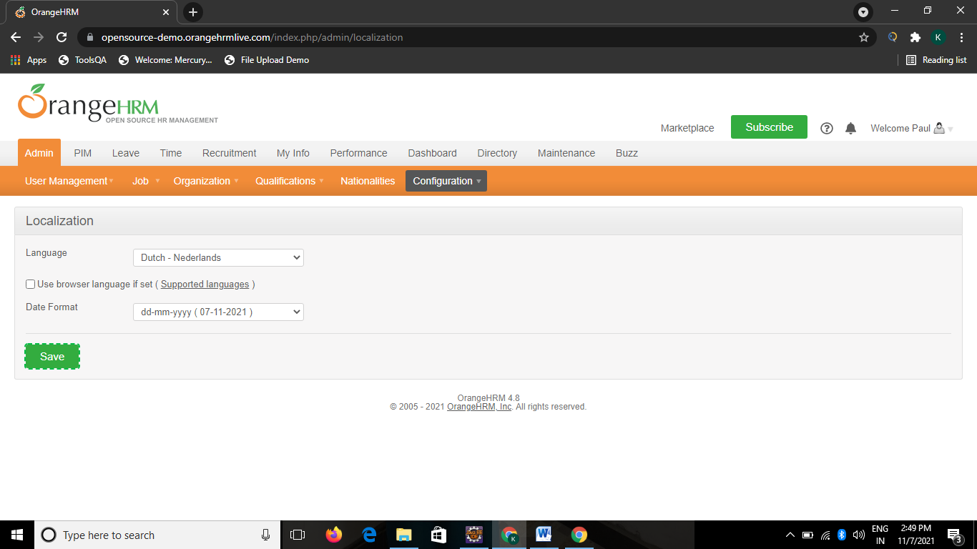w.findElement(By.xpath("/html[1]/body[1]/div[1]/div[3]/div[1]/div[2]/form[1]/fieldset[1]/p[1]/input[1]")).click();

# TC29- To Check the functionality of Configuration with language package Button

Actions A16 = new Actions(w);

A16.moveToElement(w.findElement(By.linkText("Configuration"))).build().perform();

w.findElement(By.linkText("Language Packages")).click();

w.findElement(By.xpath("//*[@id=\"btnAdd\"]")).click();

Select s8 = new Select(w.findElement(By.name("addLanguagePackage[name]")));

s8.selectByVisibleText("English (India)");

w.findElement(By.name("btnSave")).click();

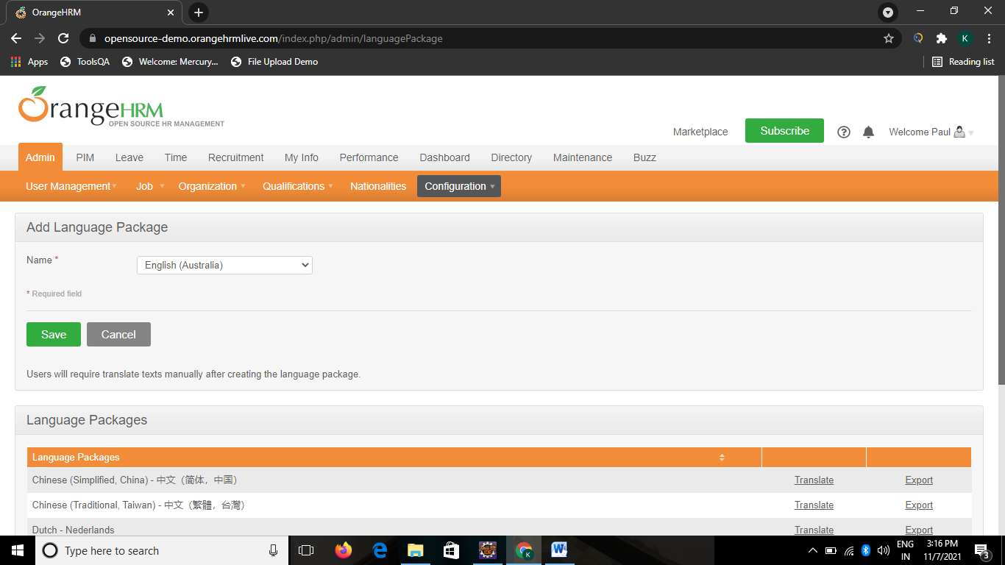

**TC30-To check the functionality of Configuration with Modules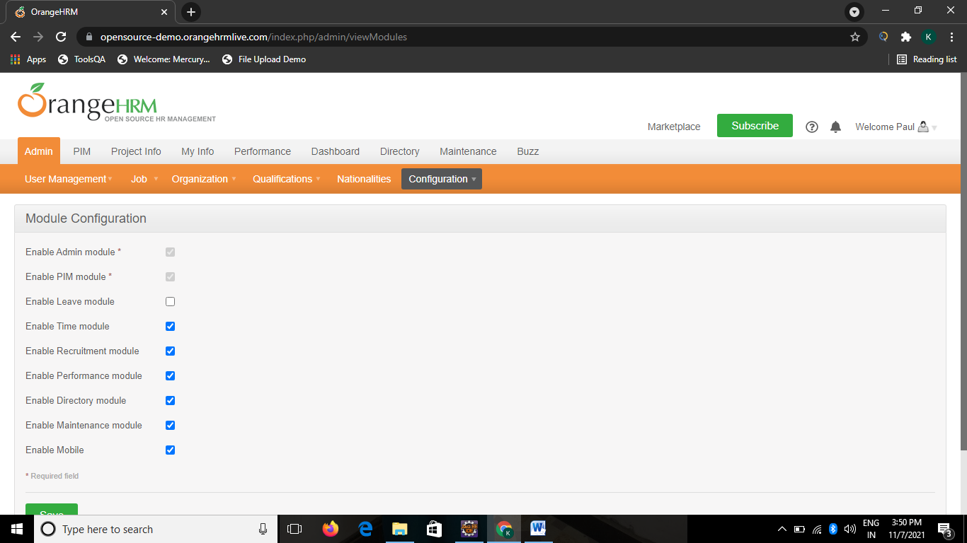 Button**

Actions A17 = new Actions(w);

A17.moveToElement(w.findElement(By.linkText("Configuration"))).build().perform();

w.findElement(By.linkText("Modules")).click();

w.findElement(By.xpath("//*[@id=\"btnSave\"]")).click();

w.findElement(By.id("moduleConfig_leave")).click();

w.findElement(By.xpath("//*[@id=\"btnSave\"]")).click();

# TC31-To check the functionality of Configuration with social media authentication Button

Actions A18 = new Actions(w);

A18.moveToElement(w.findElement(By.linkText("Configuration"))).build().perform();

w.findElement(By.linkText("Social Media Authentication")).click();

w.findElement(By.name("btnAdd")).click();

Select s9 = new Select(w.findElement(By.name("openIdProvider[type]")));

s9.selectByVisibleText("OpenId");

w.findElement(By.name("openIdProvider[name]")).sendKeys("open");

w.findElement(By.name("openIdProvider[url]")).sendKeys("https://opensource-demo.orangehrmlive.com/index.php");

w.findElement(By.xpath("//*[@id=\"btnSave\"]")).click();

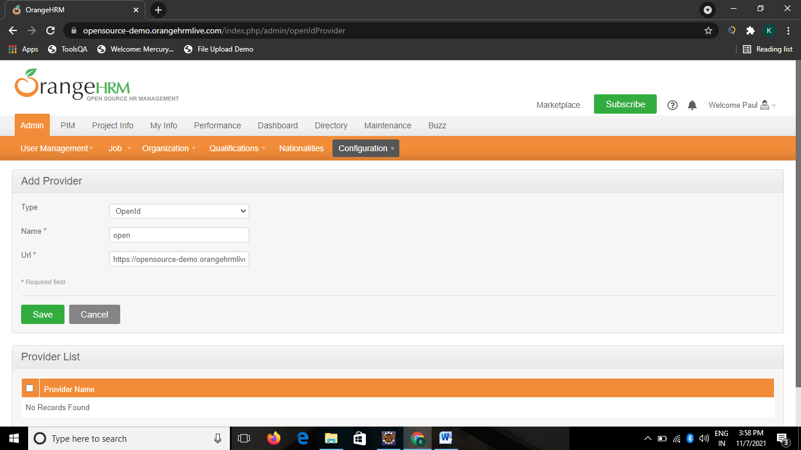

# TC32-To check the functionality of PIM with configuration Button

w.findElement(By.xpath("//*[@id=\"menu_pim_viewPimModule\"]")).click();

Actions A13 = new Actions(w);

A13.moveToElement(w.findElement(By.linkText("Configuration"))).build().perform();

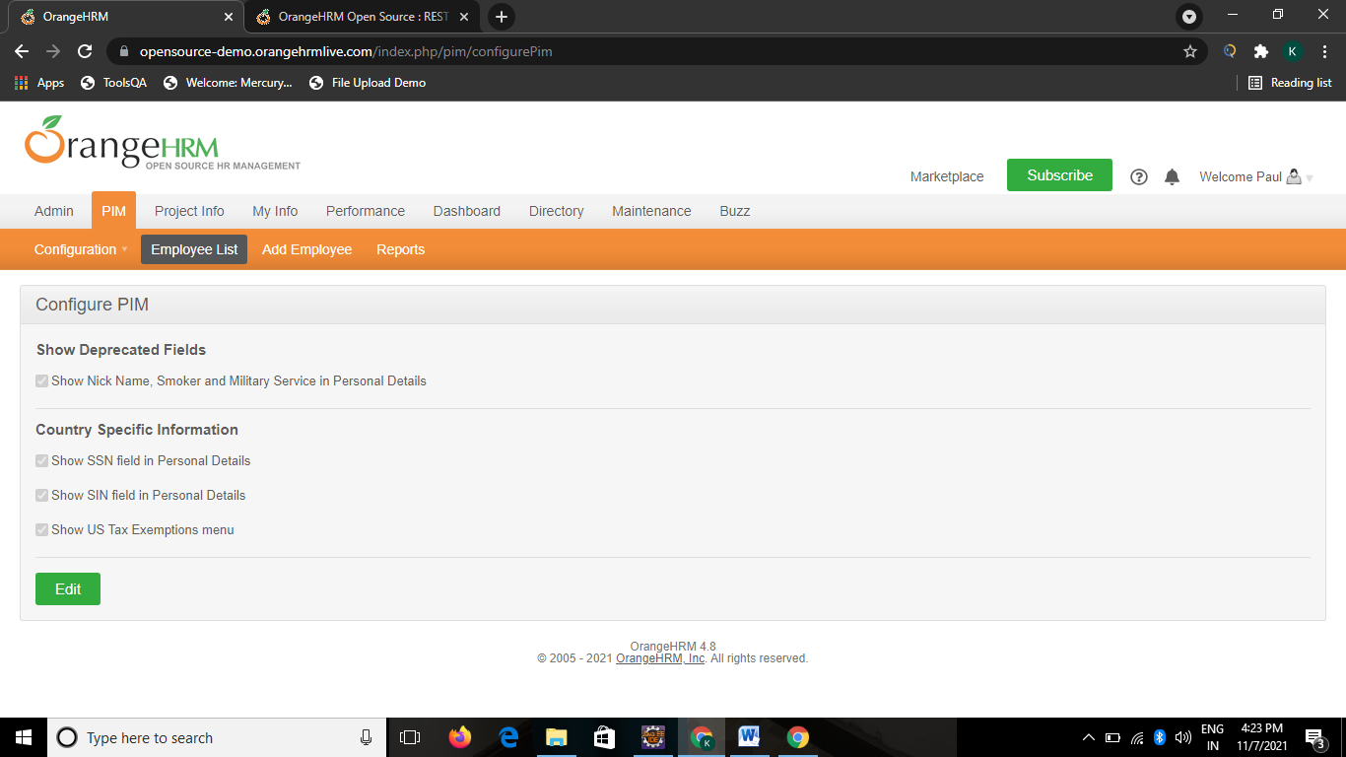

# TC33-To check the functionality of PIM configuration with optional fields Button

w.findElement(By.linkText("Optional Fields")).click();

w.findElement(By.xpath("/html[1]/body[1]/div[1]/div[3]/div[1]/div[2]/form[1]/fieldset[1]/p[1]/input[1]")).click();

w.findElement(By.xpath("//*[@id=\"frmConfigPim\"]/fieldset/ol[2]/li[2]/label")).click();

w.findElement(By.xpath("//*[@id=\"btnSave\"]")).click();

# TC34-To Check the functionality of PIM Configuration with custom fields Button

Actions A14 = new Actions(w);

A14.moveToElement(w.findElement(By.linkText("Configuration"))).build().perform();

w.findElement(By.linkText("Custom Fields")).click();

w.findElement(By.xpath("//*[@id=\"buttonAdd\"]")).click();

w.findElement(By.name("customField[name]")).sendKeys("Blood Type1");

Select s10 = new Select(w.findElement(By.name("customField[screen]")));

s10.selectByVisibleText("Contact Details");

Select s11 = new Select(w.findElement(By.name("customField[type]")));

s11.selectByVisibleText("Text or Number");

w.findElement(By.xpath("//*[@id=\"btnSave\"]")).click();

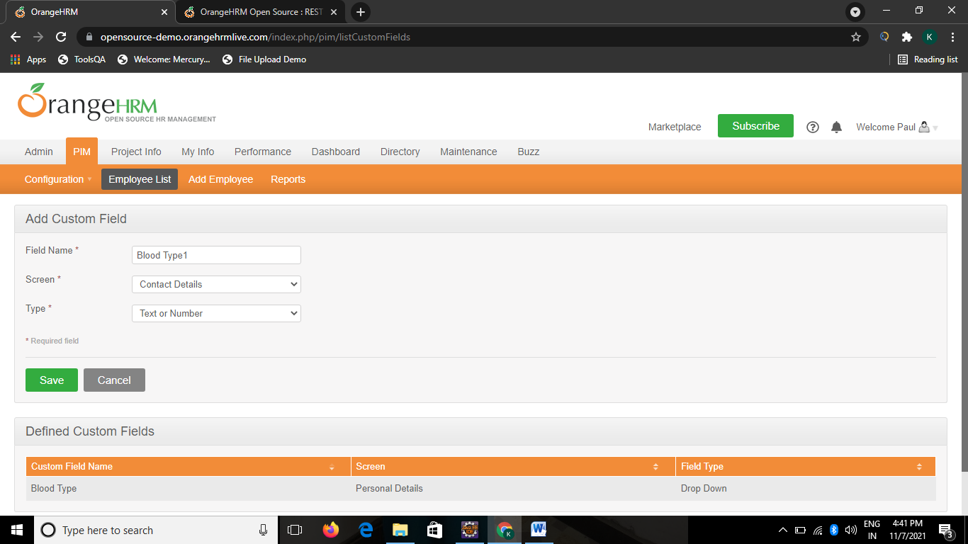

# TC35-To check the functionality of PIM configuration with reporting methods Button

Actions A15 = new Actions(w);

A15.moveToElement(w.findElement(By.linkText("Configuration"))).build().perform();

w.findElement(By.linkText("Reporting Methods")).click();

w.findElement(By.xpath("//*[@id=\"btnAdd\"]")).click();

w.findElement(By.name("reportingMethod[name]")).sendKeys("Direct1");

w.findElement(By.xpath("//*[@id=\"btnSave\"]")).click();

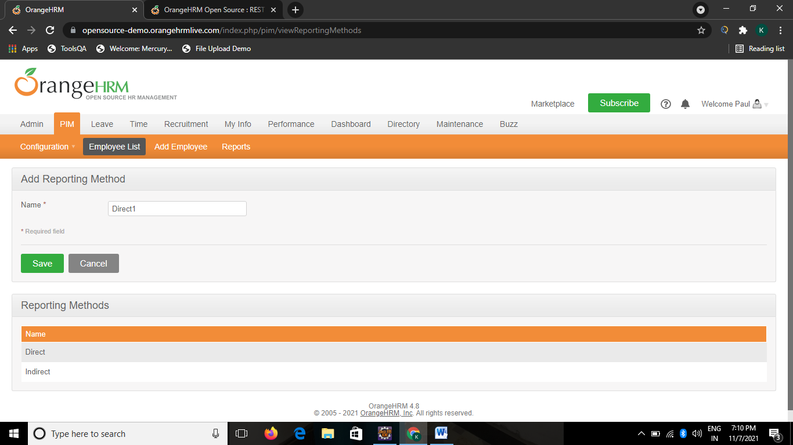

# TC36-To check the functionality of PIM Configuration with termination reasons Button

Actions A16 = new Actions(w);

A16.moveToElement(w.findElement(By.linkText("Configuration"))).build().perform();

w.findElement(By.linkText("Termination Reasons")).click();

w.findElement(By.xpath("//*[@id=\"btnAdd\"]")).click();

w.findElement(By.name("terminationReason[name]")).sendKeys("Retired1");

w.findElement(By.xpath("//*[@id=\"btnSave\"]")).click();

# TC37-To check the functionality of cancel Button

Actions A17 = new Actions(w);

A17.moveToElement(w.findElement(By.linkText("Configuration"))).build().perform();

w.findElement(By.linkText("Termination Reasons")).click();

w.findElement(By.xpath("//*[@id=\"btnAdd\"]")).click();

w.findElement(By.xpath("//*[@id=\"btnCancel\"]")).click();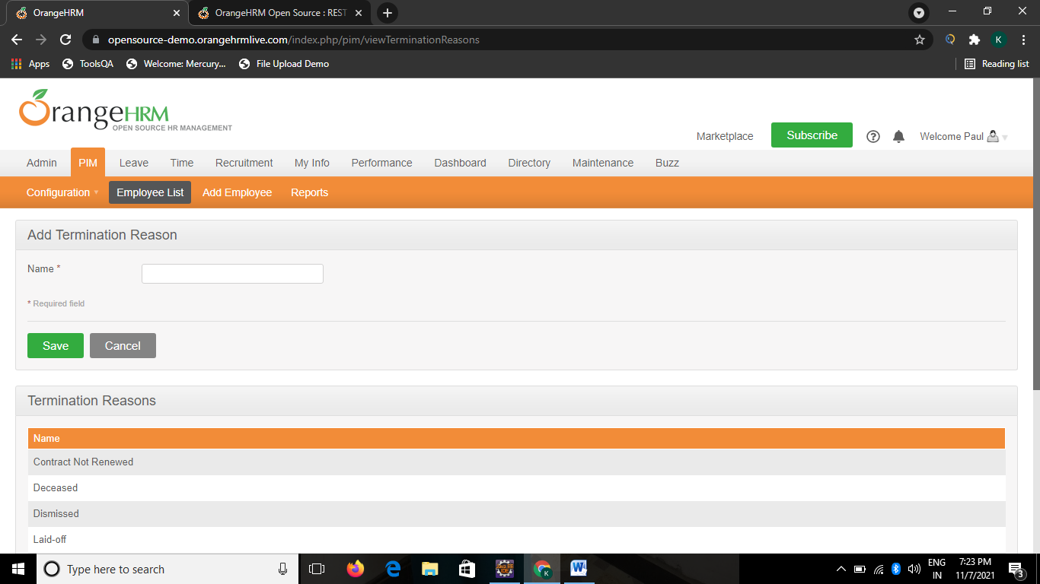

# TC38-To Check the functionality of PIM with employee list Button

w.findElement(By.xpath("//*[@id=\"menu_pim_viewPimModule\"]")).click();

w.findElement(By.linkText("Employee List")).click();

w.findElement(By.xpath("//input[@id='btnAdd']")).click();

w.findElement(By.name("firstName")).sendKeys("Jasmin");

w.findElement(By.name("lastName")).sendKeys("morgan");

w.findElement(By.xpath("//*[@id=\"btnSave\"]")).click();

**TC39-To check the functionality of personal details Button**

w.findElement(By.xpath("//*[@id=\"btnSave\"]")).click();

w.findElement(By.xpath("//*[@id=\"frmEmpPersonalDetails\"]/fieldset/ol[3]/li[1]/ul/li[2]/label")).click();

Select s11 = **new** Select (w.findElement(By.name("personal[cmbNation]")));

s11.selectByVisibleText("Indian");

w.findElement(By.name("personal[DOB]")).click();

Select s12 = **new** Select(w.findElement(By.xpath("//*[@id=\"ui-datepicker-div\"]/div/div/select[1]")));

s12.selectByVisibleText("Dec");

Select s13 = **new** Select(w.findElement(By.xpath("//*[@id=\"ui-datepicker-div\"]/div/div/select[2]")));

s13.selectByVisibleText("2018");

w.findElement(By.xpath("//*[@id=\"ui-datepicker-div\"]/table/tbody/tr[2]/td[4]/a")).click();

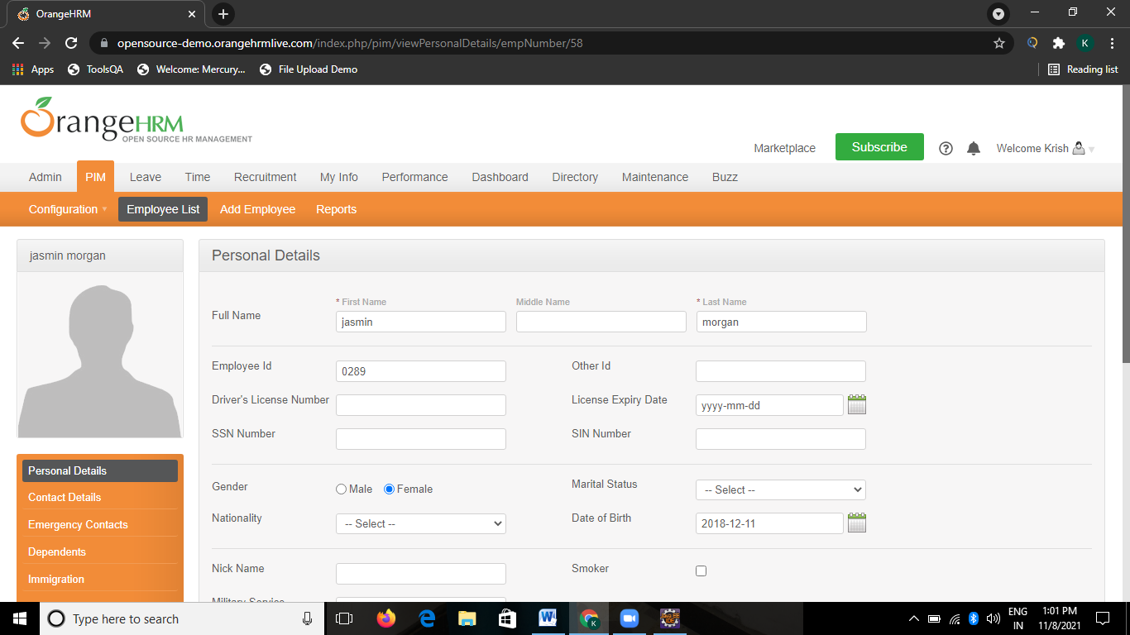w.findElement(By.xpath("//*[@id=\"btnSave\"]")).click();

# TC40-To check the functionality of Emergency contacts Button

w.findElement(By.linkText("Emergency Contacts")).click();

w.findElement(By.id("btnAddContact")).click();

w.findElement(By.name("emgcontacts[name]")).sendKeys("jasmin");

w.findElement(By.name("emgcontacts[relationship]")).sendKeys("friends");

w.findElement(By.name("emgcontacts[homePhone]")).sendKeys("8989457389");

w.findElement(By.name("btnSaveEContact")).click();

# TC41-To check the functionality of Dependents Button

w.findElement(By.linkText("Dependents")).click();

w.findElement(By.id("btnAddDependent")).click();

w.findElement(By.name("dependent[name]")).sendKeys("jasmin");

Select s15 = new Select(w.findElement(By.name("dependent[relationshipType]")));

s15.selectByVisibleText("Child");

w.findElement(By.name("btnSaveDependent")).click();

# TC42-To check the functionality of Immigration button

w.findElement(By.linkText("Immigration")).click();

w.findElement(By.xpath("//*[@id=\"btnAdd\"]")).click();

w.findElement(By.xpath("//*[@id=\"frmEmpImmigration\"]/fieldset/ol/li[1]/ul/li[2]/label")).click();

w.findElement(By.name("immigration[number]")).sendKeys("4567873478");

Select s16 = new Select(w.findElement(By.name("immigration[country]")));

s16.selectByVisibleText("India");

w.findElement(By.xpath("//*[@id=\"btnSave\"]")).click();

# TC43-To check the functionality of next button

w.findElement(By.xpath("//*[@id=\"menu_pim_viewPimModule\"]")).click();

w.findElement(By.linkText("Employee List")).click();

w.findElement(By.xpath("//*[@id=\"frmList_ohrmListComponent\"]/div[1]/ul/li[5]/a")).click();

# TC44- To check the functionality of Forgot your password Button

w.findElement(By.xpath("//a[contains(text(),'Forgot your password?')]")).click();

w.findElement(By.name("securityAuthentication[userName]")).sendKeys("Admin");

w.findElement(By.xpath("//*[@id=\"btnSearchValues\"]")).click();

# 

# 

# TC45- To check the functionality of Browser Open

System.setProperty("webdriver.gecko.driver", "C:\\Users\\hp\\Desktop\\seleniumjar\\geckodriver-v0.30.0-win64\\geckodriver.exe");

WebDriver w=new FirefoxDriver();

w.get("https://opensource-demo.orangehrmlive.com/index.php/admin/viewAdminModule");

TC46- To check the functionality of Heading of website

w.findElement(By.id("divLogo"));

TC46- To check the functionality of Browser Open

w.manage().window().maximize();

w.findElement(By.id("txtUsername")).sendKeys("Admin");

w.findElement(By.id("txtPassword")).sendKeys("admin123");

w.findElement(By.id("btnLogin")).click();

# 

# TC47- To check the functionality of Leave

w.findElement(By.id("menu_leave_viewLeaveModule")).click();

T**C48-To check the functionality of Apply In Leave**

w..findElement(By.id("menu_leave_applyLeave")).click();

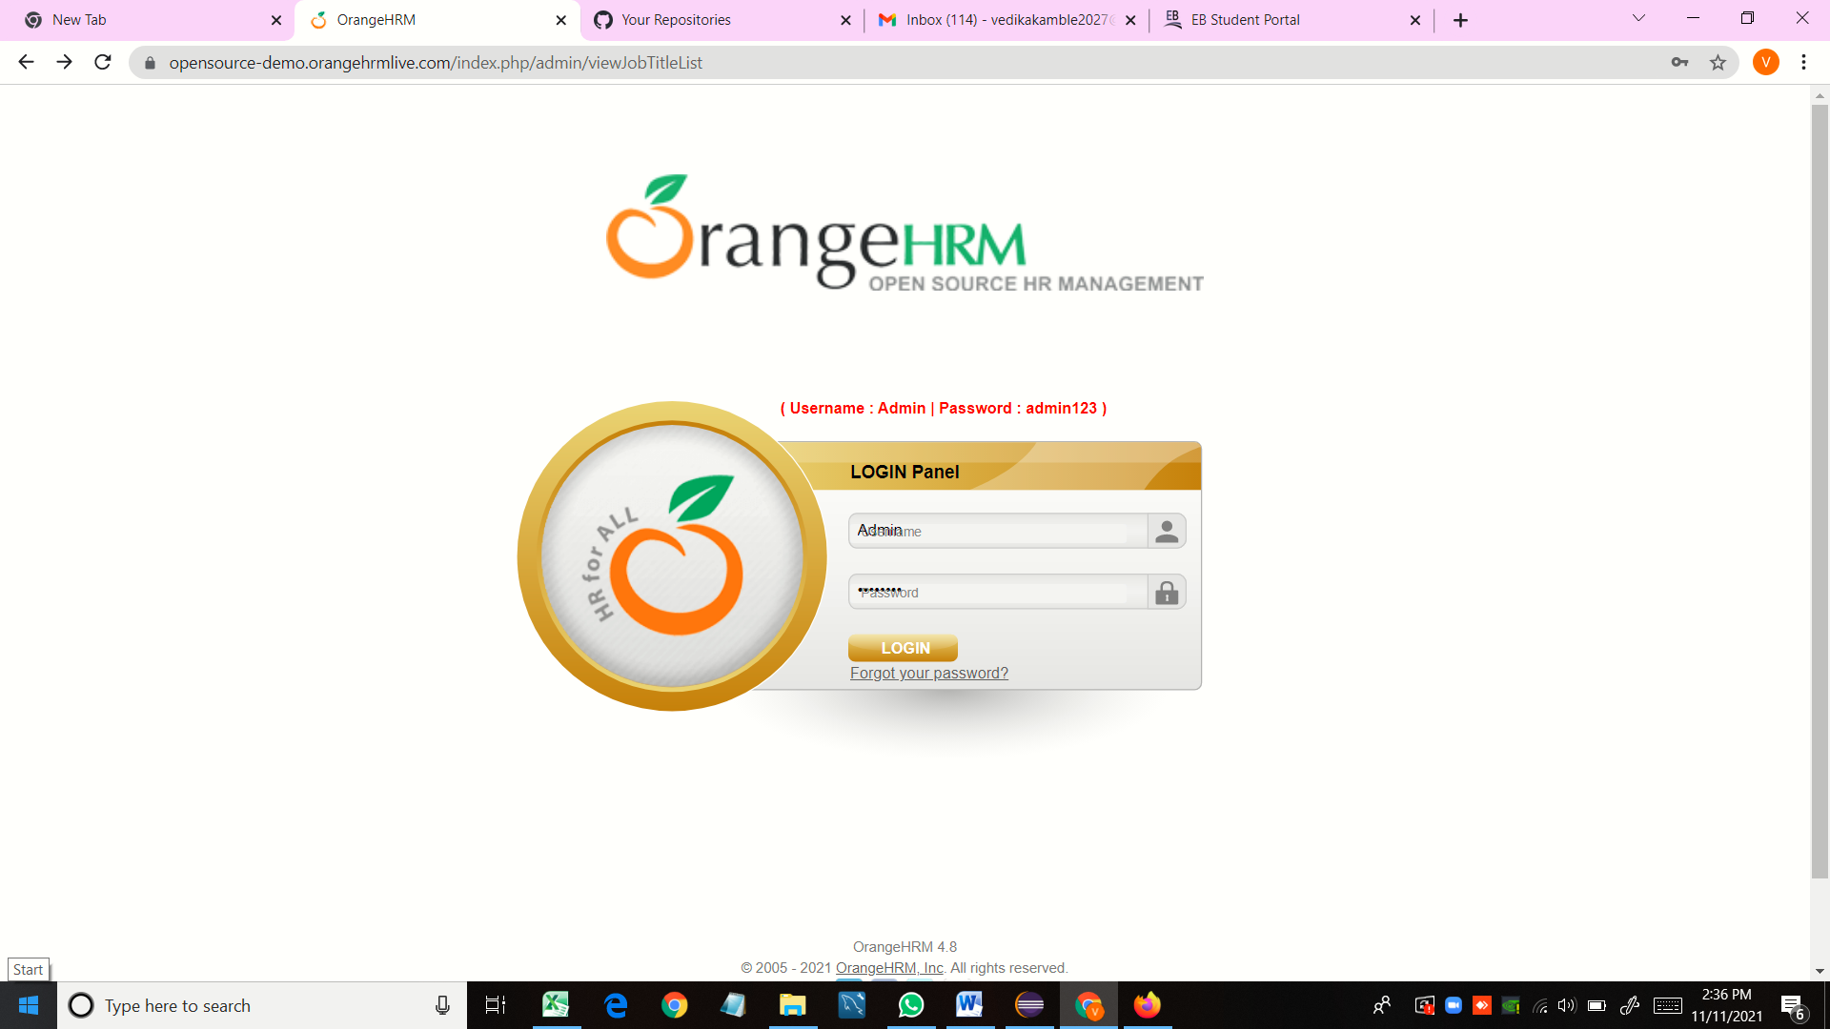

# TC 49- To check the functionality of apply date from

w.findElement(By.id("applyleave_txtLeaveType")).click();

# TC50- To check the functionality of apply date to

Select s3 = new Select(w.findElement(By.id("applyleave_txtLeaveType")));

s3.selectByValue("1");

# TC51- To check the functionality of show leave with status

w.findElement(By.className("ui-datepicker-trigger")).click();

# TC52- To check the functionality of to

w.findElement(By.id("calToDate")).click();

# TC53- To check the functionality of From

w.findElement(By.className("ui-datepicker-trigger")).click();

# TC54- To check the functionality of show leave with status

w.findElement(By.id("leaveList_chkSearchFilter_checkboxgroup_allcheck")).click();

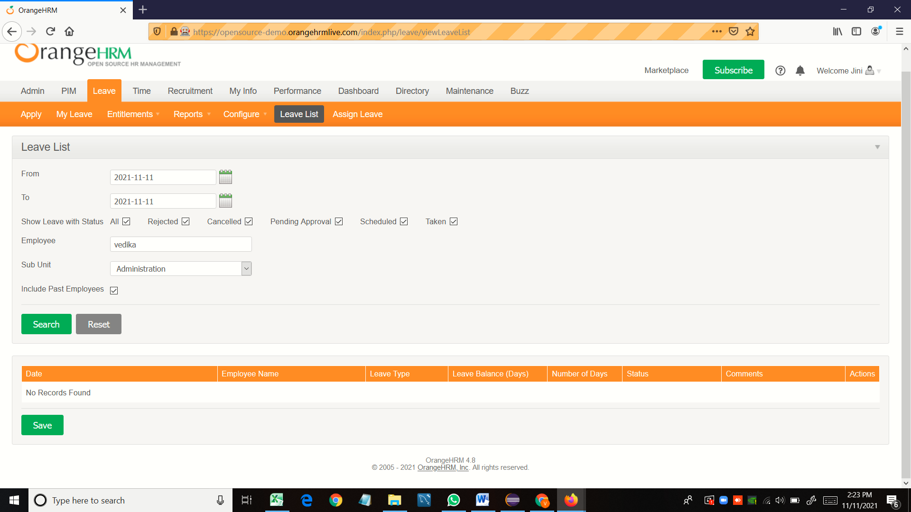

# TC55- To check the functionality of Employee

w.findElement(By.id("leaveList_txtEmployee_empName")).sendKeys("vedika");

# TC56- To check the functionality of Subunit

Select s4 = new Select(w.findElement(By.id("leaveList_cmbSubunit")));

s4.selectByValue("1");

# TC57- To check the functionality of Include Past Employees

w.findElement(By.id("leaveList_cmbWithTerminated")).click();

## TC58- To check the functionality of Search Button

w.findElement(By.id("btnSearch")).click();

# TC59- To check the functionality of Reset Button

w.findElement(By.id("btnReset")).click();

# TC60- To check the functionality of entitlement

Select s5 = new Select(w.findElement(By.id("menu_leave_Entitlements")));

s5.selectByValue("1");

TC61- To check the functionality of of entitlement in the employee entitlement Add to multiple Employees

w.findElement(By.id("entitlements_filters_bulk_assign")).click();

# TC 62- To check the functionality of of entitlement in tha employee entitlement with Employee name

w.findElement(By.id("entitlements_employee_empName")).sendKeys("vedika");

# TC63- To check the functionality of Leave Type

Select s6 = new Select(w.findElement(By.id("entitlements_leave_types")));

s6.selectByValue("1");

# TC64- To check the functionality of Leave Period

Select s7 = new Select(w.findElement(By.id("period")));

s7.selectByValue("1");

# TC65- To check the functionality of Entitlement TextField

*w.findElement(By.id("entitlements_entitlement")).sendKeys("miss");*

# TC66-To check the functionality of Search Button

w.findElement(By.id("btnSave")).click();

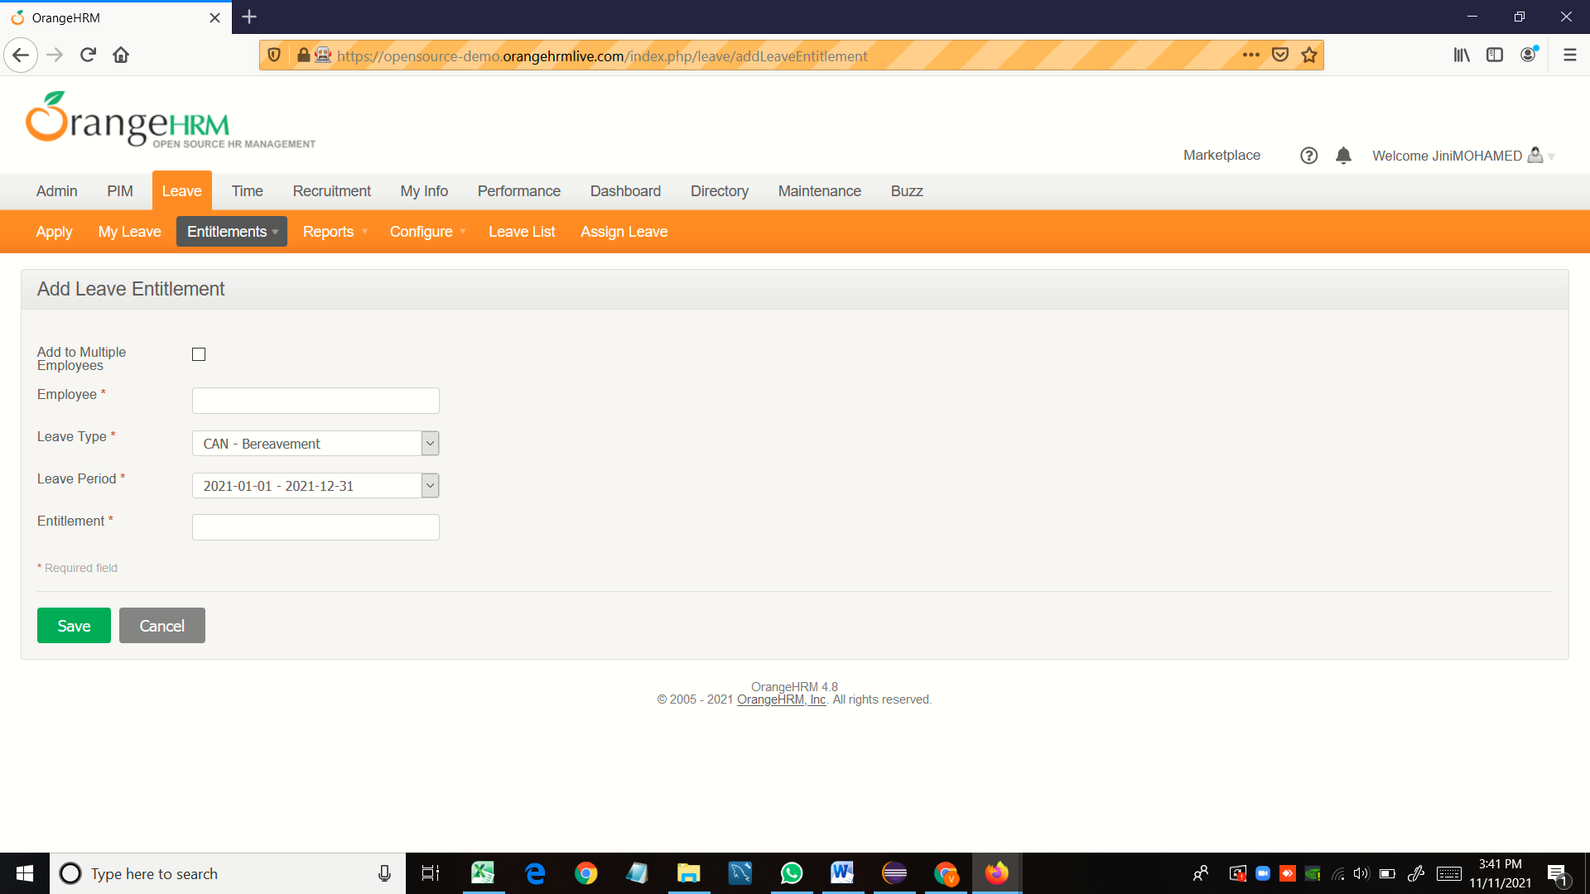

## TC67-To check the functionality of Cancel Button

w.findElement(By.id("btnCancel")).click();



# TC68-To check the functionality of Reports

Select s8 = new Select(w.findElement(By.id("menu_leave_Reports")));

s8.selectByValue("1");

# TC69-To check the functionality of Leave entitlement and usage reports

w.findElement(By.id("menu_leave_viewLeaveBalanceReport")).click();

# TC70-To check the functionality of Generate For

Select s9 = new Select(w.findElement(By.id("leave_balance_report_type")));

s9.selectByValue("1");

# 

# 



 

